Easter Sunday  Reading I: Acts 10:34a, 37-43  Responsorial Psalm: 118:1-2, 16-17, 22-23  Reading II: Colossians 3:1-4 or 1 Cor 5:6b-8  Gospel: John 20:1-9 or Matthew 28:1-10  or Luke 24:13-35  Readings may be found on the US Bishop’s website:  https://bible.usccb.org/bible/readings/040923.cfm | 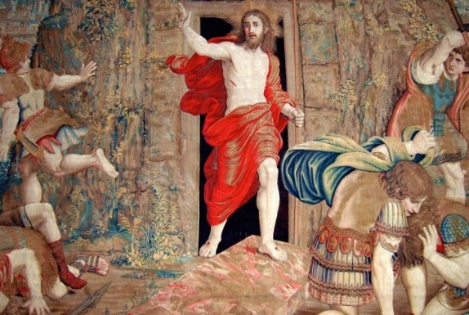
The scriptures for Easter Sunday present a range of responses and implications for understanding the resurrection of Jesus. Mary Magdalene responds with concern for Jesus. For her it is relational. She comes early in the morning, “while it was still dark.” She sees that the stone is rolled away and runs to tell the disciples that Jesus’ body has been taken.
Peter and the other disciple run to the tomb to investigate what has happened. They see the burial cloths and that Jesus’ body is no longer there. It would not be normal for thieves to remove the burial cloths. It would take too much time. Remember when Lazarus came out of the tomb, he came out in burial linens. For the “other” disciple, the empty tomb leads him to believe in the resurrection, but he does not understand it. Peter does not yet believe. He is still trying to understand and conceive this new event. He only comes to believe in seeing the Lord later that day when Jesus appears to him.
For early Christians and us, the challenge continues. How can this event be integrated into our faith and our life? We cannot easily access the empty tomb and for most people, Jesus will not appear to us. There is the testimony of the early disciples, but they cannot be questioned about further details.
Acceptance of the resurrection will be based on one’s relationship with Jesus. If one encounters Jesus in prayer, one will believe. If Jesus is a regular part of one’s life, a person will know Jesus as the living Lord. If Jesus remains just an idea or a person from long ago, then the concept of resurrection will seem unreasonable. The encounter with Jesus will make all the difference. One needs to be open to the ways that Jesus chooses to reveal himself in a person’s life. Jesus does this in different ways for each individual.
The reading from the Acts of the Apostles presents a sample early Christian proclamation of the Gospel. Peter is preaching to a group of Gentiles and he offers the key elements of the Christian message: the earthly ministry of Jesus and his rejection by the Jewish community who sought to put him to death; God reverses that judgment by raising him from the dead; and that the apostles are witnesses to his ministry and his appearances after his resurrection.
Included in this passage is the note that they ate and drank with him after his resurrection. The connection between meals and the presence of Jesus invites all believers to greater awareness as we participate in the Eucharistic liturgy.
In the Letter to the Colossians, we are reminded that there is a new orientation to life. Each believer has been given a new life in Christ. This new life is hidden from ordinary view but it will be revealed when Christ is revealed. As believers, each person shares in the dying and rising of Christ. Christ is now hidden and so this new life is hidden within us. When Christ is revealed, so will this new life that is within us be revealed.

Themes:
Resurrection Eucharist
Implications of Baptism Eternal Life

Reflection questions:
What are you seeking?
Is Jesus a living figure in my life? Do I have an ongoing relationship with Jesus each day?
How do you encounter the Risen Lord?
What are the key elements of the Christian faith in your words?
How do you share your faith?
How do you perceive your life in Christ as hidden now and how does it show through in your daily life?

Prayer:
For the Church: that we may radiate the light of Christ each day and confidently live as daughters and sons of God
For all the newly baptized: that they may faithfully follow Jesus and keep the light of Christ burning in their lives
For all the baptized: that Christ will pour out the Spirit upon us and enable us to continue the mission of bringing hope, meaning, and love to all in our society
For all who find themselves walking in darkness or doubting their faith: that they may encounter the Risen Lord who brings light to their journey and peace to their hearts
For healing of hearts and relationships: that the Risen Lord will open the path to reconciliation and healing for families, communities, and co-workers

© Joseph Milner, 2023

